MD2201: Data Science

Name of the student: Rajeev Tapadia Roll No. : 67

Div:C Batch: 3

Date of performance:

Experiment No.2

Title: Laboratory on Statistics
Aim: To find the probability for Binomial distribution and Normal distribution and verify the Normal approximation of Binomial distribution.

Software used: Programming language R.

Code Statement:
Write a single R code to answer the following questions.

Data Set: Travelled Abroad

- Find out the % of Indians in the sample who have travelled abroad using the data source.
- # 1. Find out the % of Indians in the sample who have travelled abroad
- p <- mean(dataset$Travelledabroad == "Y")
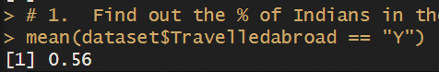
- Treating this value as ‘p’, calculate the following probabilities –
  - What is the probability that in a randomly chosen sample of 10 persons, no one has travelled abroad?
  - What is the probability that in a randomly chosen sample of 10 persons, exactly one has travelled abroad?
  - What is the probability that in a randomly chosen sample of 10 persons, exactly two persons have travelled abroad?
  - What is the probability that in a randomly chosen sample of 10 persons, exactly three persons have travelled abroad?
  - What is the probability that in a randomly chosen sample of 10 persons, exactly four persons have travelled abroad?
  - What is the probability that in a randomly chosen sample of 10 persons, exactly five persons have travelled abroad.
  - What is the probability that in a randomly chosen sample of 10 persons, exactly six persons have travelled abroad?
  - What is the probability that in a randomly chosen sample of 10 persons, exactly seven persons have travelled abroad?

  - What is the probability that in a randomly chosen sample of 10 persons, exactly eight persons have travelled abroad?
  - What is the probability that in a randomly chosen sample of 10 persons, exactly nine persons have travelled abroad?
  - What is the probability that in a randomly chosen sample of 10 persons, all 10 persons have travelled abroad?
- # b. exactly one person travelled abroad
- dbinom(1, size = 10, prob = p)
- # Probability that exactly 2 persons have traveled abroad
- dbinom(2, size = 10, prob = p)
- # Probability that exactly 3 persons have traveled abroad
- dbinom(3, size = 10, prob = p)
- # Probability that exactly 4 persons have traveled abroad
- dbinom(4, size = 10, prob = p)
- # Probability that exactly 5 persons have traveled abroad
- dbinom(5, size = 10, prob = p)
- # Probability that exactly 6 persons have traveled abroad
- dbinom(6, size = 10, prob = p)
- # Probability that exactly 7 persons have traveled abroad
- dbinom(7, size = 10, prob = p)
- # Probability that exactly 8 persons have traveled abroad
- dbinom(8, size = 10, prob = p)
- # Probability that exactly 9 persons have traveled abroad
- dbinom(9, size = 10, prob = p)
- # Probability that exactly 10 persons have traveled abroad
- dbinom(10, size = 10, prob = p)

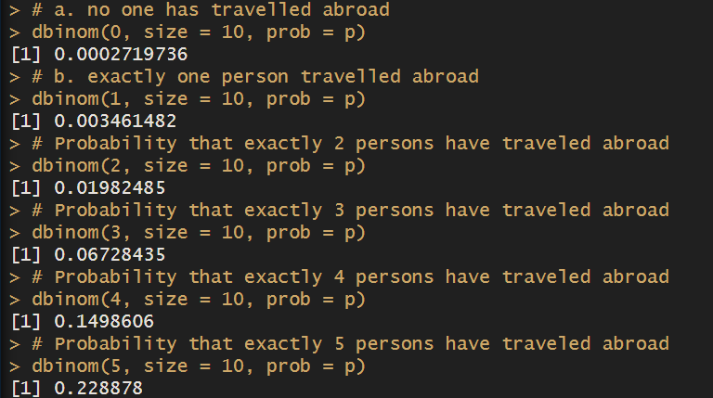

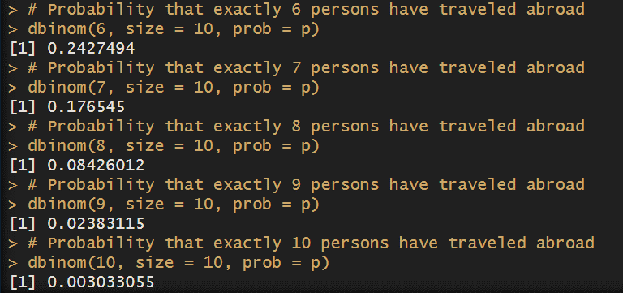

- Plot the probability values as a Table / Bar graph/plot and interpret plot.
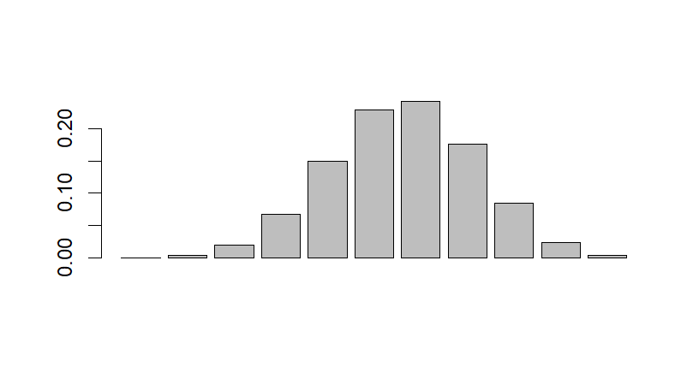

- What is the probability that in the randomly chosen sample of 100 persons at least 59 have travelled abroad?
Hint: Expected to perform Normal approximation for the binary distribution.

no_sample <- 100
mu <- no_sample * p
sigma <- sqrt(no_sample * p * (1-p))
z <- (59 - mu)/sigma
1 - pnorm(z)

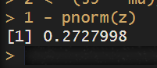

Conclusion:

The analysis will provide insights into travel patterns and demonstrate how the Normal distribution can be used to approximate the Binomial distribution under certain conditions.

